Culture sleeping
Sleeping with pets
Sleeping with your pet might disturb you from sleeping well. But researches who surveyed pet owners, have shown that people who have slept with their pets were provided with warmth, happiness and relaxation- all of which should help a good night’s sleep.
Siestas
Although siestas are believed to be originated to give Spanish farmers time to rest in hot climates a few thousand years ago, many European countries practice this nap pause. Bodies tend to get tired in the early afternoon, therefore siestas are indeed a way of boosting energy.

Naked sleeping
According to a study from National Sleep Foundation, the United Kingdom has a preference for sleeping naked. A possible connection between the comfort of being free of clothes, and a good sleep can be further studied.
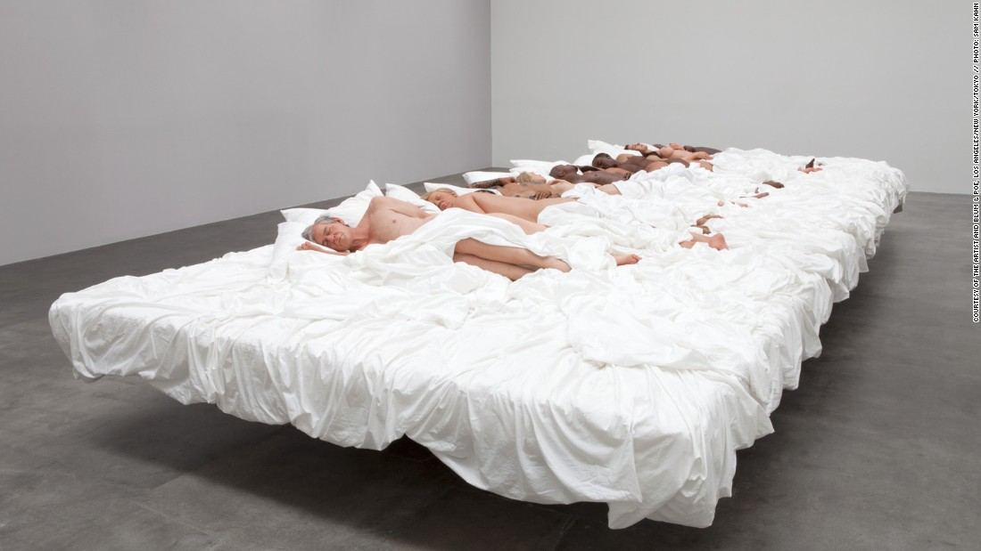

Napping in public
The Japanese practice of inemuri, or sleeping while present is a very interesting way of resting while still going on with your day- this is seen as a sign of hard work. ‘Dozing’ is sometimes done on a park bench or a train, at a dinner party or even during a gathering. This can be sighted in Paris, especially on the metro and trains, people on their way to work or on their way back- half awake half asleep, almost daydreaming in public.
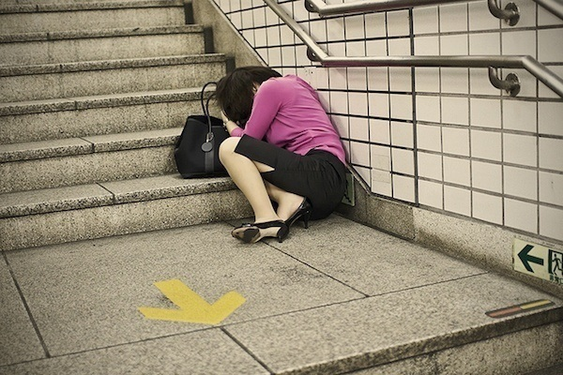

Bedtime prayers
In Mexico, meditation or prayer are common before bed. In a 2013 survey by the National Sleep Foundation study, 62% of Mexicans said they prayed or meditated in the hour before going to sleep. Unlike watching TV or looking at electronics, which can actually make it harder to drift off, the quietness of prayer or meditation can help induce sleepiness.
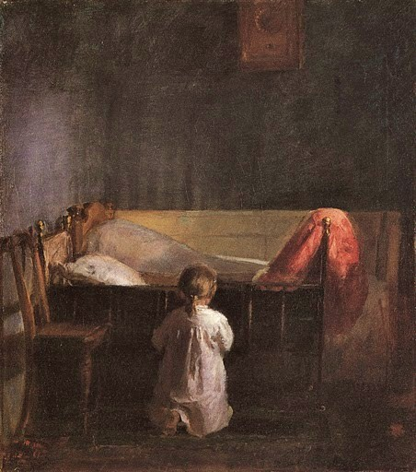

Sleeping with the right sheets
It may surprise you to know that your bed sheets and pillowcases may be to blame for a bad sleep. Choosing the right kind of sheets, its’ weight, fabric materials and the number of layers, can be a key to good night’s sleep.

Worry dolls
The indigenous people of Guatemala’s highlands create “worry dolls” to help them sleep. Pieces of wood or wire make up the doll frame, and artists add yarn and woven fabric to give the dolls traditional Mayan costumes. According to Mayan legend, someone whose worries prevent them from sleeping should tell their concerns to as many dolls as necessary. Then they put the dolls under their pillow, and the dolls take over worrying so the person can sleep soundly and wake up unburdened in the morning.
